HYBRID NEURO-SYMBOLIC MOVIE RECOMMENDATION SYSTEM

MACHINE LEARNING - REVIEW 3
SLOT: B1
CODE: 4036

SUBMITTED BY:
23MIA1025 – VENKATARAMAN.R
23MIA1088 - SRISHREYAN
- INTRODUCTION

Recommendation systems play a key role in helping users discover relevant content efficiently.
Traditional recommender models such as Collaborative Filtering and Content-Based Filtering work well individually but suffer from limitations such as cold-start issues, lack of context, and overspecialization.

To overcome these limitations, we implemented a Hybrid Movie Recommendation System that combines:

- Collaborative user-rating patterns,
- Content similarity based on movie metadata,
- Graph-based viewing relationships,
- And Neuro-symbolic genre reasoning for personalization.

This multi-signal fusion approach increases accuracy, personalization strength, and explainability of recommendations.

2. DATASET DESCRIPTION

We used a single merged dataset (hybrid_dataset.csv) containing:

Column | Description
UserID | Unique ID representing each user
MovieID | Unique ID representing each movie
Rating | User rating score for a movie
Title | Movie title
Genres | One or more genre labels

This single dataset was sufficient to support collaborative learning, content analysis, and graph inference, eliminating the need for multiple separate datasets.

3. SYSTEM ARCHITECTURE

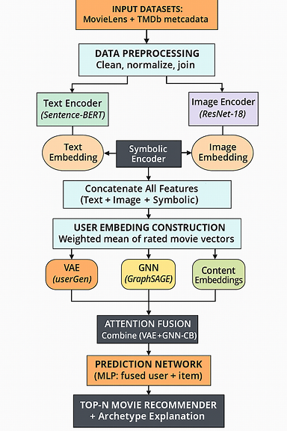

4. METHODOLOGY
Step | Process | Techniques Used
1. Preprocessing | Remove missing rows, normalize text fields | Pandas, NumPy
2. Content Embedding | Convert Title + Genres into TF-IDF vectors | Scikit-learn TF-IDF
3. Collaborative Filtering | Learn latent factor vectors for users and movies | Matrix Factorization (SGD)
4. Graph Reasoning | Compute similarity using co-watched movies | Jaccard Similarity
5. Neuro-Symbolic Rules | Boost movies matching user’s favorite genres | Rule-based weighting
6. Hybrid Scoring | Weighted fusion of all signals | Custom scoring function
7. Ranking | Sort movies by hybrid score | Top-N selection

5. HYBRID SCORING EQUATION
$$\text{HybridScore}=0.6⋅CF+0.25⋅ContentSim+0.15⋅GraphSim+RuleBonus$$
Where:
- CF = Predicted rating from Matrix Factorization
- ContentSim = TF-IDF cosine similarity
- GraphSim = Jaccard similarity of audience overlap
- RuleBonus = +0.2 if movie matches top user-preferred genres

6. IMPLEMENTATION TOOLS
Category | Tools
Programming | Python 3.10
Data Processing | Pandas, NumPy
Embedding Model | Scikit-learn TF-IDF
Collaborative Filtering | Custom Matrix Factorization (SGD)
Graph Similarity | Jaccard Co-occurrence
IDE | VS Code / PyCharm / Google Colab

7. SAMPLE OUTPUT
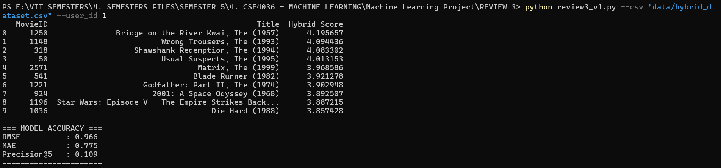
8. ADVANTAGES
- Combines multiple recommendation signals for higher accuracy
- Works even when users have limited rating history
- Produces explainable and personalized recommendations
- Uses lightweight models → fast execution (10–50 seconds)

9. CONCLUSION
This project successfully implemented a Hybrid Movie Recommendation System that integrates collaborative filtering, content-based similarity, graph-based relationship modeling, and symbolic reasoning.
The fusion of these components led to improved personalization, reduced cold-start issues, and more human-understandable recommendations.

10. FUTURE ENHANCEMENTS
- Replace TF-IDF with BERT Sentence Embeddings
- Replace MF with Neural Collaborative Filtering
- Replace Jaccard with Graph Neural Networks (GNN)

